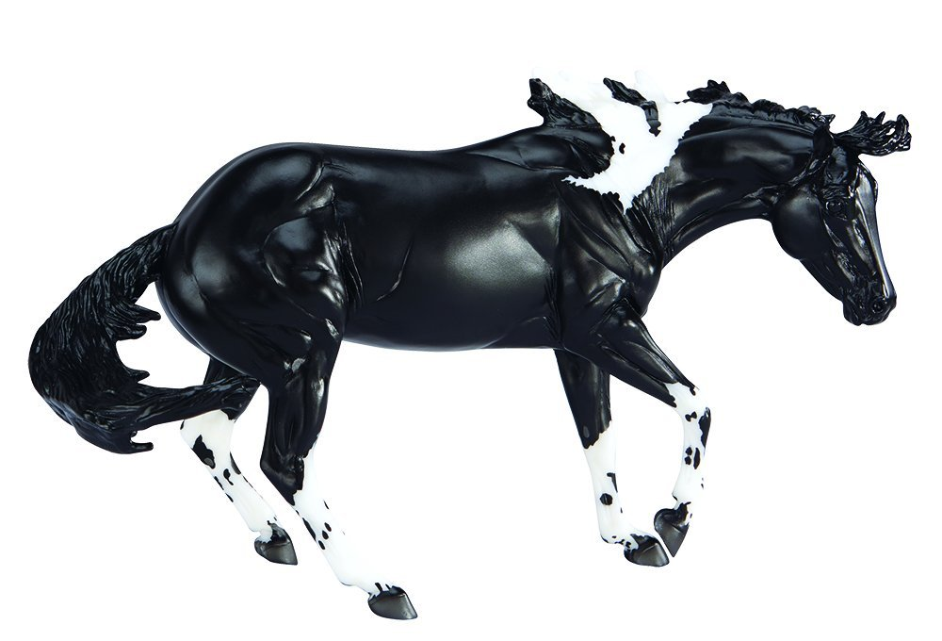
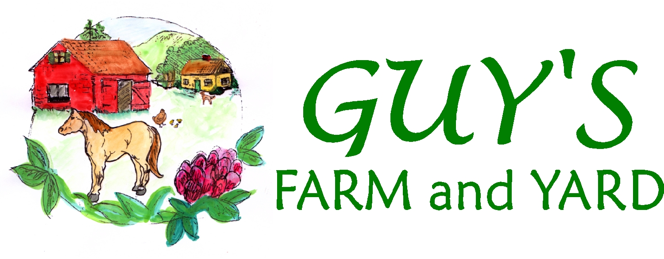
Presents:
Vermont Live Model Horse Show & Fun Day!

DATE: Sunday, October 29, 2017
TIME: Judging starts promptly at 9:00 AM
LOCATION: Guy’s Farm and Yard, 21 Zephyr Road, Williston, Vermont
JUDGES: Jill O’Connor, Robin Briscoe, Kelly Martin
Name:
Address:

Phone: Email:
Entry Fees: | By October 20th
Sunday Novice Model Horse Show | $25
Sunday Intermediate Model Horse Show | $35
Vendor Space (without or with table) | $10/$20
Late Fee (after October 20th) | $10
Total Amount Enclosed:

Model Horse Show Regional Tag ID #
Payment Enclosed (please make checks payable to Guy’s Farm and Yard)

Check #: Money Order:
Credit Card (Visa/Mastercard/Discover):
Number: Exp.
Name on Card-Printed: Signature:
Please mail completed Model Horse Fun Day and Show form by October 20th to:

Guy’s Farm & Yard
Model Horse Fun Day and Show
PO Box 471
Williston, VT 05495
Have questions? Feel free to contact us via email at williston@guysfarmandyard.com by phone at (802) 878-5112 or visit us on the web at www.guysfarmandyard.com

TIMES: The Show Hall will open to exhibitors at 7:30 AM to prepare set up. Judging will begin promptly at 9:00 AM.

FOOD: A concession stand will be open to provide coffee, donuts, hamburgers, hot dogs, sandwiches, etc; you are more than welcome to bring your own food!

ENTRY CHANGES: You may add 2 additional horses the morning of the show until 9:00 AM so long as you are not over your limits. You should enter all horses you expect to bring even if you decide to scratch them at the last minute. Those using the Region X tags, please register your horses on the website https://regionxnation.com and bring an updated list of models with you the day of the show.

RESULTS: Results will be posted on the Region X Yahoo group site. If you would rather have the results mailed to you, please bring along a self-addressed stamped envelope and drop it off at the registration table the morning of the show.

VENDORS: Space is limited; please call ahead to reserve your space. Cost is $10/space with your table; $20/space with table provided by Guy’s Farm and Yard. No current line Breyer Model horses, please.

LIMITS: The same horses and tack may not be used by two different showers regardless of the division they are showing in.

HALTER CLASSES: Halters are not required, but are allowed. No props of any kind may be used except when showing chinas, where a piece of protective material may be placed under the model. In that instance, the judge reserves the right to have the owner turn the model over to check the other side. If you are showing an unusual breed of horse, you may provide no more then one 8.5”x 11” inch sheet of paper for documentation. Three (3) horses per exhibitor in halter classes.

PERFORMANCE CLASSES: Appropriate tack and props are required, use of dolls is optional. A note explaining your entry is required in all performance classes, except pleasure classes. Two (2) horses per exhibitor in performance classes.

Breed & Gender Designation: Please be sure to list the breed of your model on the registration form. Ponies, Drafts, and Warmbloods must have an actual breed noted (i.e. Shetland, Clydesdale, Oldenburg). If you are showing an unusual breed, please feel free to provide a description of the breed (a photo is also helpful). This should be no larger than 8.5”x 11”. Please also note if the horse is a stallion, gelding, mare, colt or filly.

ORIGINAL FINISH (OF): For this show it is to be understood to be the original finish model straight out of the packaging. Any mass produced or single produced factory model will fall into this category. Examples are Breyer, Stone, Hartland, etc. Models such as this with tack or props added for a class is still considered OF.

CUSTOMIZED (CM) or ARTIST RESIN (AR): For this show it is to be understood to be any type of model where anything was changed from the original or was not a factory horse. For example, a model horse that has a blaze added or been fully remodeled/painted is considered custom (CM). Novices must have completed their customized models by themselves.

TIME LIMITS: Three minutes between halter classes and approximately 5 minutes between performance classes at the judges’ discretion. While ring 1 is being judged ring 2 will be setting up and vice-versa. In an effort to make the day move this will be strictly enforced.

TAGS: This show participates in the Region X Tag system. If you do not already have a Region X number and would like one, please sign up on the Region X website http://regionxnation.com Please be sure to register your horses prior to the show on the same website. Be sure to print off your show horse list and provide it to the show secretary Sunday AM. All showers are encouraged to join the Region X Tag system. This allows for easy record keeping for both those showing, and those managing the show.

CHAMPIONSHIPS: All first and second places from each class will be called to the ring for a show Championships.

BASIC RULES for Showers and Spectators:
- Please do not touch or pick up a model that does not belong to you.“You break it, you bought it.”
- There will be no talking to the judge while they are judging a class.
- Once a class has started, only the judge and assistant may be in the ring area.
- The judge’s decision is final.
- Keep noise level down during the show to hear announcements of classes.
- Keep your area neat, clean and free of any empty boxes or large items.
- Alcohol, bad language, smoking, pets, radios and running in the building is not allowed.
- Poor sportsmanship will not be tolerated.
- All children under 12 must be accompanied by an adult.
- Everyone must strive for a fun, enjoyable, rewarding day.

Directions to Guy’s Farm and Yard:
From Interstate 89 Exit 12, turn north on Route 2A and right onto Zephyr Road.

Local hotels:
Fairfield Inn by Marriott ~ 2844 St. George Rd, Williston, VT 05495 ~ 802-879-8999
Holiday Inn ~ 1068 Williston Rd, South Burlington, VT 05403 ~ 802-863-6363

Lunchtime Fun Classes:
1. Most Loved (note to explain why)
2. Animal
These classes will be voted on during lunchtime by the other participants and spectators.

Novice Class List: Starting at 9:00 AM (non NAN qualifying classes)
 | Ring 1 |  | Ring 2
1. | Diorama/Barn Scene (3 foot max.) | 2. | English (jumping, dressage, pleasure, etc)
3. | Western (pleasure, roping, etc) | 4. | Costume
5. | Other Performance (racing, harness, etc) | 6. | Champion Performance
7. | Breyer regular run 2005 to current | 8. | Breyer regular run 2004 and before
9. | Breyer special runs (JC Penney, Holiday,  JAH Collectors, etc) | 10. | Other Make (Peter Stone, Barbie, etc)
11. | Light Breed (Morgan, Arab, Saddlebred) | 12. | Sport Breed (TB, Warmbloods, Standardbred)
13. | Stock Horses (QH, Appy, Mustang, etc) | 14. | Spanish Breed (Paso Fino, Andalusian, etc)
15. | Other Breeds (Friesan, Longears, Exotic) | 16. | Pony
17. | Draft Horses | 18. | Half / Mixed breeds
19. | Foals | 20. | Unusual color (unicorns, blue horses, horse-like only)
21. | Championship Halter | 22. | Customized by owner

- For this show, a novice is defined as someone who has not won a champion or reserve at a novice or open show.
- Limited to 20 models total.
- Test runs, raffle models, One-Of-A-Kind’s, Connoisseur, and other rare models in production runs of 350 or less can not be shown in this division.
- Documentation suggested for performance and collectability as well as unusual breeds.
- The same horse can show in both halter and performance classes.
- The same horse can show in two halter classes, one for breed and one for collectability. In breed it will be judged on breed standards and condition and in collectability it will be judged on rarity and condition.
- The same horse may be shown in more than one performance class. It would just need appropriate tack and set-up changes.

Intermediate Class List: Starting at 9:00 AM (non NAN qualifying classes)
 | Ring 3 |  | Ring 4
1. | Diorama/Barn Scene (3 foot max) | 2. | Costume
3. | Jumping | 4. | Other English (saddleseat, dressage)
5. | English Pleasure | 6. | Trail (English/Western)
7. | Gymkhana/Games (English/Western) | 8. | Other Western (reining, roping)
9. | Western Pleasure | 10. | Other Performance (racing, harness, etc)
11. | Championship Performance | 12. | Breyer regular run 2004 and before
13. | Breyer regular run 2005 to Current | 14. | Breyer special runs (JC Penney, Holiday,  JAH Collectors, etc)
15. | Other Makes (Peter Stone, Hagen Rehnker, etc) | 16. | Championship Collectability
17. | Thoroughbred/Standardbred | 18. | Warmblood/ Other Sport Horse
19. | Morgan | 20. | Arab/NSH/Part Arab
21 | American Gaited Breeds | 22. | Spanish Breeds
23. | Other light breeds | 24. | Quarter Horse
25. | Paint | 26. | Appaloosa
27. | Other Stock Horse (Mustang, etc) | 28. | Pony
29. | Draft | 30. | Other Pure/Part Breed
31. | Longears/Exotic | 32. | Foals
33. | Decorator/Fantasy | 34. | Championship Halter
35 | Halter Customized (workmanship judged)

- Limited to 40 horses total.
- Intermediate is defined as one who would have won championships in Novice classes but placed low in Open classes.
- Documentation strongly recommended in performance and collectability, suggested for breed classes.

BREED GUIDELINES:

AMERICAN GAITED BREEDS: American Saddlebred, Tennessee Walking Horse, National Show Horse, Rocky Mountain Horse, Missouri Foxtrotter, American Racking Horse, etc.

DRAFT BREEDS: Suffolk, Shire, Clydesdale, Percheron, Jutland, Gypsy, etc.

LONGEARS/EXOTICS: Donkey, Mule, Hinny, Poitou, Zebra, Przewalskii, Wild Ass, Quagga, Onager, etc.

PONY BREEDS: British Shetland, Highland, Welsh A, B, & C, Exmoor, Dartmoor, Dales, Fell, Connemara, New Forest, Highland, Hackney, Eriskay, Haflinger, Fjord, Chincoteague/Assateague, Potok, Konik, POA, Quarter Pony, Icelandic, Gotland, etc.

SPANISH BREEDS: Andalusian, Lipizzan, Lusitano, Paso Fino, Peruvian Paso, Barb, Hispano-Arab, etc.

STOCK BREEDS: Includes the American Quarter Horse, Appaloosa, Paint, Canadian Cutting Horse, Azteca, etc.

WARMBLOOD/SPORT HORSE: Hanoverian, Trakehner, Dutch, Danish, Belgian, Swedish, Bavarian Warmblood, Gelderland, Frederiksborg, Selle Français, Oldenburg, Westphalian, Hessen, Holstein, Württemberg, Irish Sport Horse, Akhal-Teke, etc.

OTHER BREED:Thoroughbred crosses, such as the Anglo-Arab, Irish Sporthorse. Orlov Trotters, Finnhorses, Irish Draught, American, Canadian, Morgan Sport Horses, and Appaloosa Sport Horses also make up the Other Sport Horse division. Coaching breeds include the Friesian, Yorkshire Coach Horse, Cleveland Bay, and Dutch Tuigpaard.

OTHER PUREBRED and PARTBRED: Any pure breed that does not fit into any of the listed breed categories, such as American Bashkir Curly, Maremmana, Kathiawari, etc. Cross-bred horses that do not fit in any other category listed, as well as horses without a pedigree.

PAINT vs. PINTO: Paint refers to the breed. They are of Thoroughbred or Quarter Horse breeding. Other pinto-colored horses should be entered in their appropriate breed class, whether it be a pony, gaited breed, etc. This also applies to appaloosa/spotted horses. They may not actually be an Appaloosa just because it has spots, as in breeds such as the Colorado Ranger, Knabstrup, and Noriker-Pinzgauer. Please place these in the appropriate classes as well.

Please be specific when listing your horses breed. The judge needs to have a specific breed when judging the breed classes, as one breed of pony has different characteristics than that of another pony. It is advised to provide references and photos when showing uncommon breeds. Not only does it help educate the judge to make just pinnings, but also helps to educate fellow showers.

Name:__________________________________________________________________

Regional Tag ID #:________________________________________________________

Address:

Email:

Tag ID | Your Model’s Name | Breed | Gender | OF/CM
111-222 | Region 10 Tag Sample | Morgan | G | OF

- Please remember, Pony, Draft and Warmbloods need an actual breed (such as Shetland, Clydesdale, or Dutch Warmblood). Gender would be Stallion, Mare, Gelding, Colt, Filly.
- Model’s Name is what YOU call your horse, it doesn’t have to be the name it came
with from the factory.

