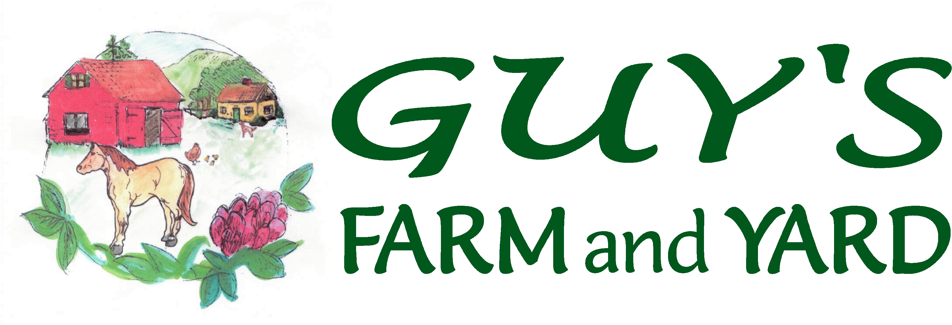
Morrisville –Montpelier –Williston – St. Albans
888-2025 229-0567 878-5112 524-9255
www.guysfarmandyard.com

Turkey Order Form 2018

Please select your pick-up date:
Order Date | Pick Up Date*
April 6th | May 8th
May 4th | June 5th
June 8th | July 10th
July 13th | August 14th

Payment due upon order. Birds MUST be picked up on specified delivery date. Minimum order 6 birds (state law).

Name: ________________________________________ Date: _______________
E-mail address: _____________________________________________________
Day Phone: ____________________ Evening Phone: ______________________

Broad Breasted White: $6.99 each  Similar to those which are raised by commercial breeders; these birds offer a fast growth rate and great feed conversion. | # Ordered:
Mammoth Bronze: $7.99 each.  These colorful birds are similar to those which are raised by commercial breeders; these birds offer a fast growth rate and great feed conversion. | # Ordered:

*Please Note: We work with the hatcheries the best we can to establish dates for pick-up. Please keep in mind that these are live animals and we cannot always control when they will hatch, or arrive. We will always call you to let you know if your birds are here, and also to update you on potential changes.

**This is a tentative date for pickup at our store; we are currently working with the hatchery to determine a firm date of pickup. We apologize for any inconvenience. All Turkeys are straight run, no exceptions.

