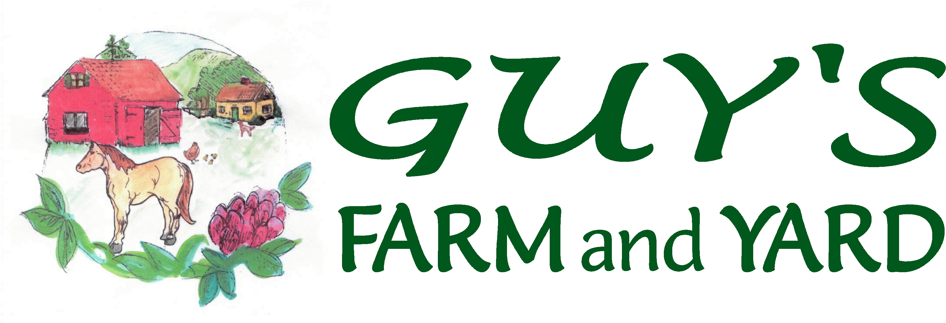
Morrisville –Montpelier –Williston – St. Albans
888-2025 229-0567 878-5112 524-9255
www.guysfarmandyard.com

Meat Bird Order Form 2018

Please select your pick-up date:
Order Date | Pick Up Date*
March 16th | April 19th
April 13th | May 17th
May 11th | June 14th
June 15th | July 19th
July 13th | August 16th

Payment due upon order. Birds MUST be picked up on specified delivery date. Minimum order 6 birds (state law).

Name:________________________________________ Date:________________
E-mail address:______________________________________________________
Day Phone:____________________ Evening Phone:_______________________

Jumbo Cornish Cross (white) - $1.25ea  Bred for efficient production of broiler meat. You can expect to have fresh, natural meat in 7-8 weeks. | # Ordered:
Red Broilers - $1.25ea  Bred for efficient production of broiler meat. These broilers rarely experience leg problems. They are more active, better suited for grazing, and grow slightly slower. | # Ordered:

*Please Note: We work with the hatcheries the best we can to establish dates for pick-up. Please keep in mind that these are live animals and we cannot always control when they will hatch, or arrive. We will always call you to let you know if your birds are here, and also to update you on potential changes.

